Wendy Bronson
Module 1.3 Programming Assignment
CSD402-300H 2271 DD
August 16th 2026

Java and JavaFX Installation and Configuration:
Figure 1Java and Java compiler version verification
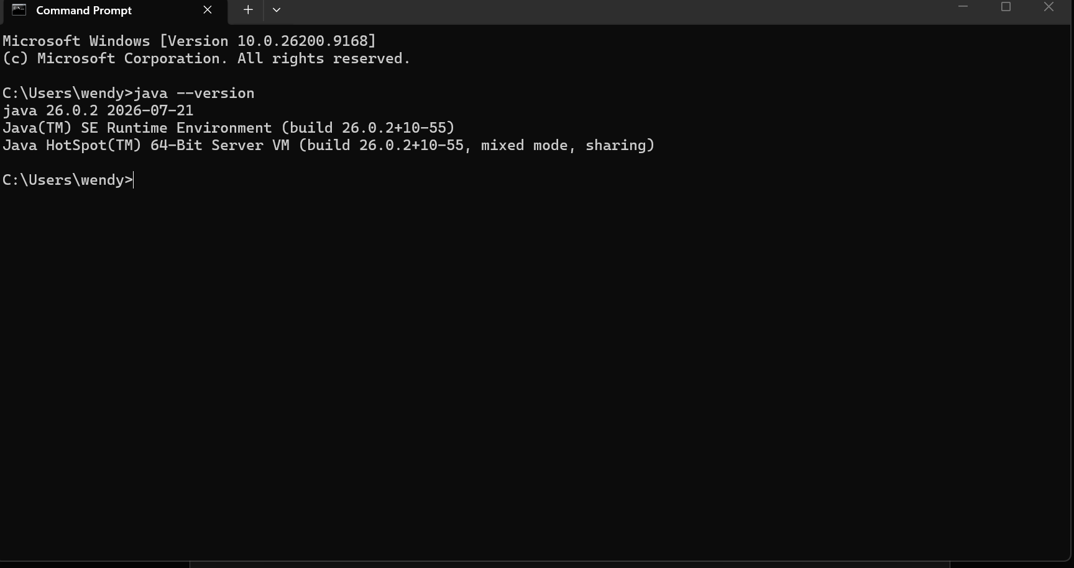
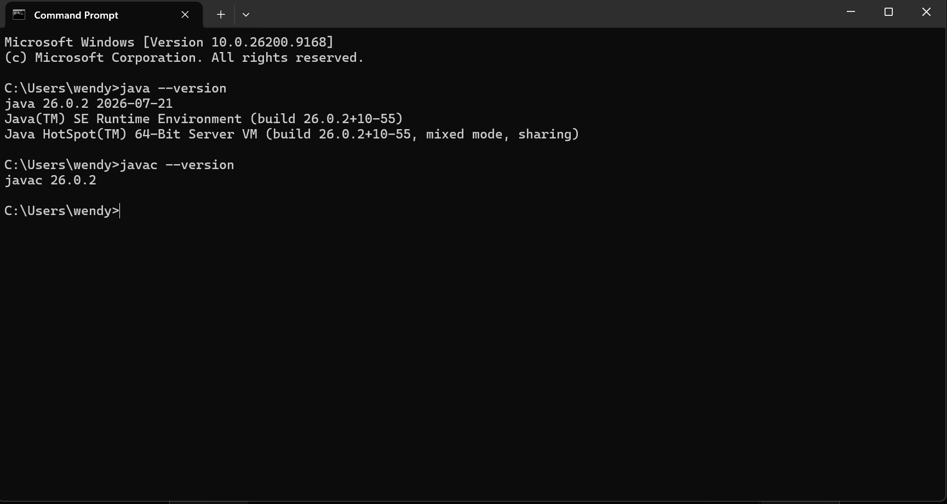
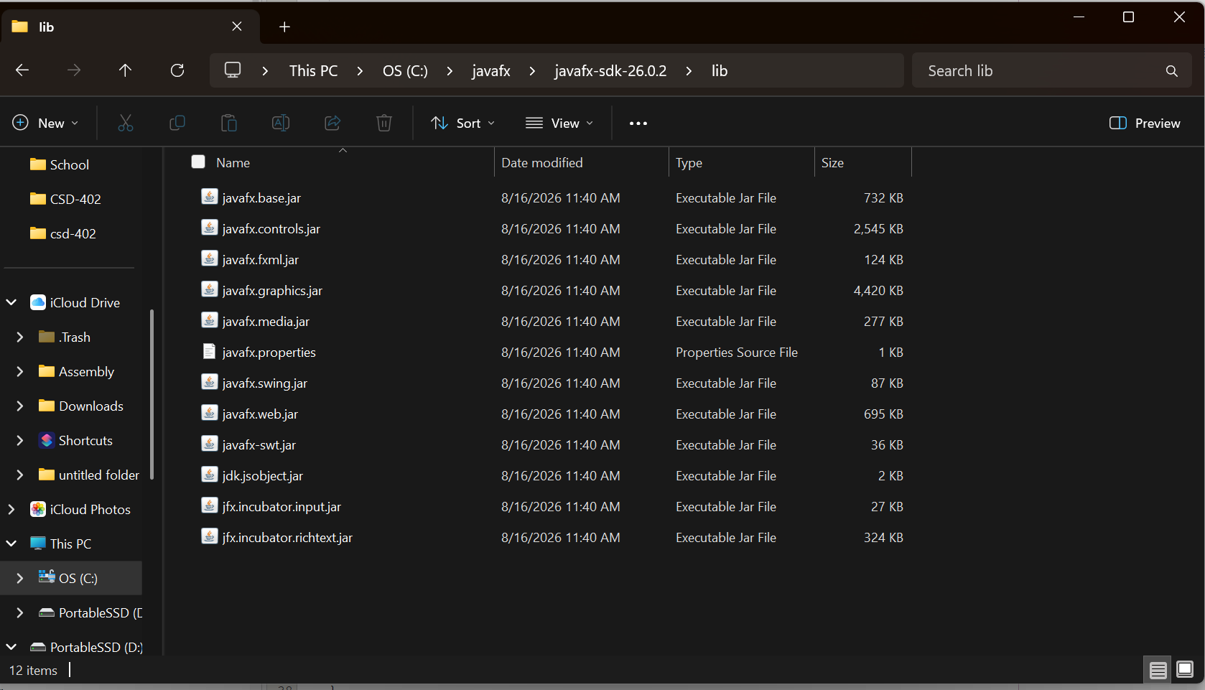
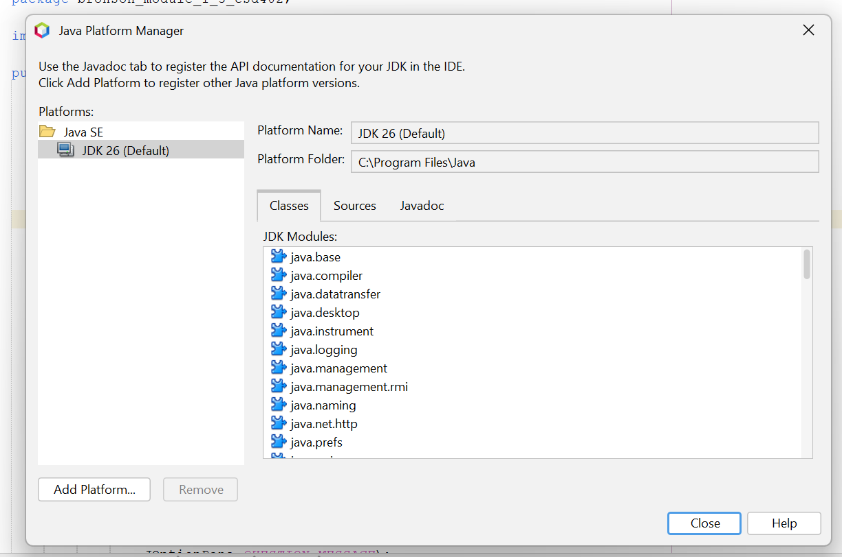
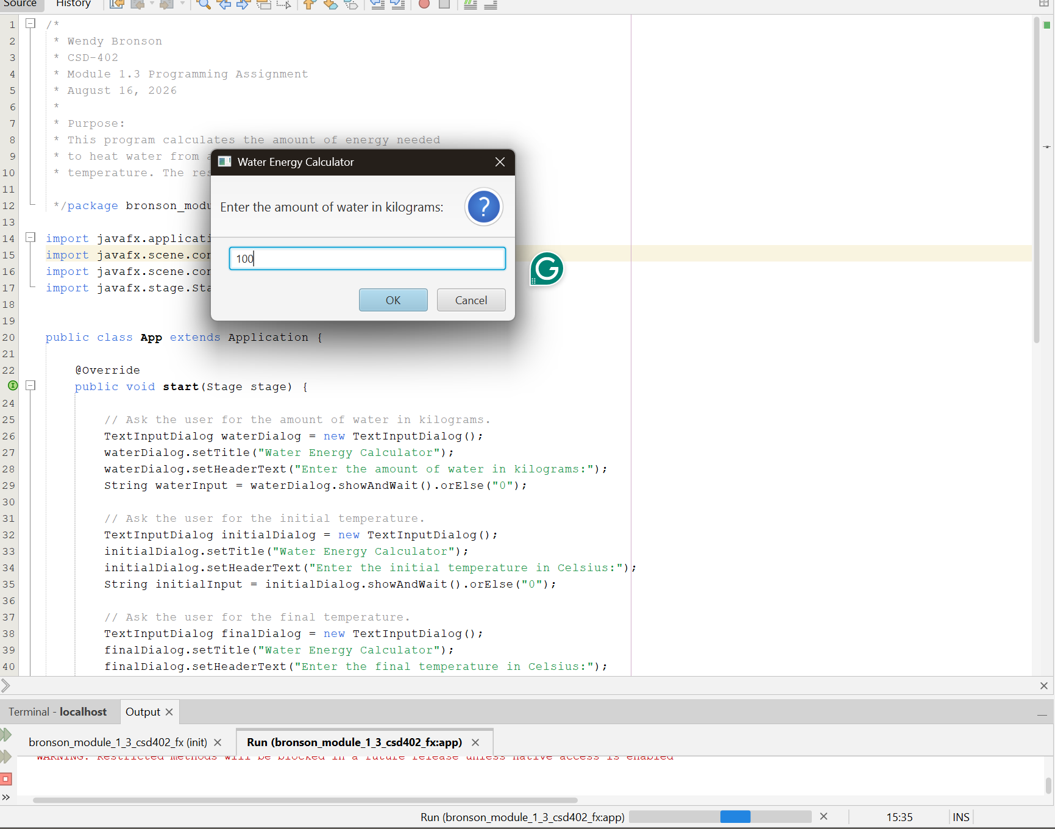

Figure 2 JavaFX 26.0.2 SDK library files installed on the computer

